GITHUB TUTORIAL DOC

1. Create a repository name in the GITHUB account page.

Click on New Button

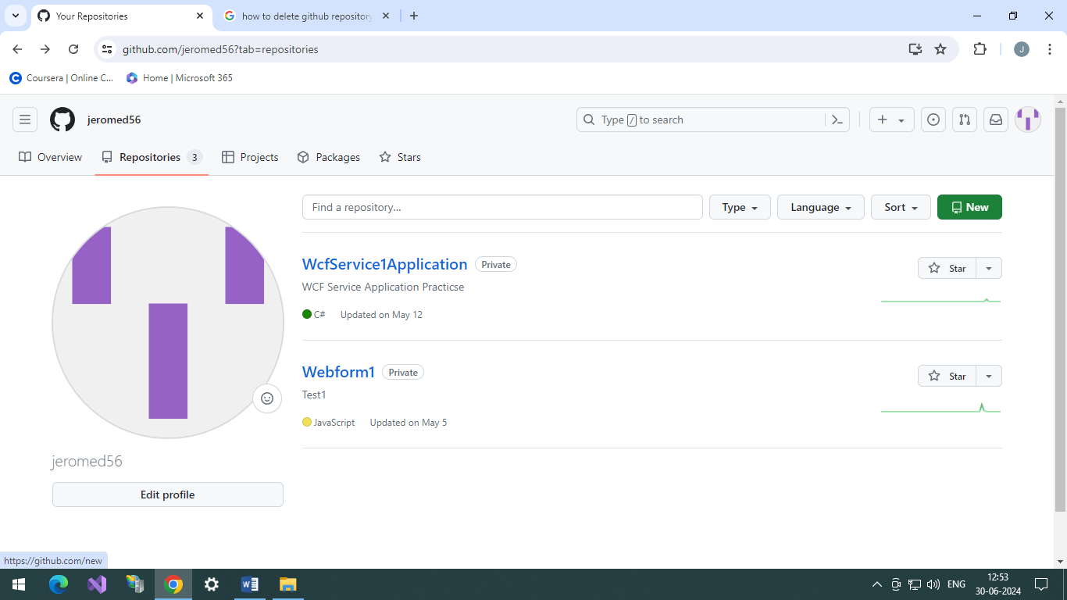

Fill in the detail like repository name ,initialize readme file and click on Create Repository button.

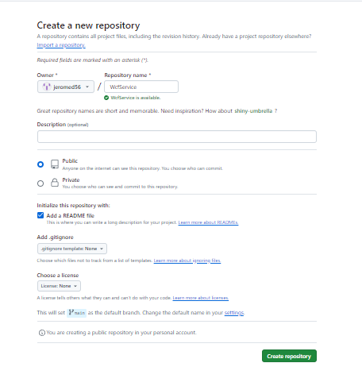

Once the Repository is created it will look something like the below image.

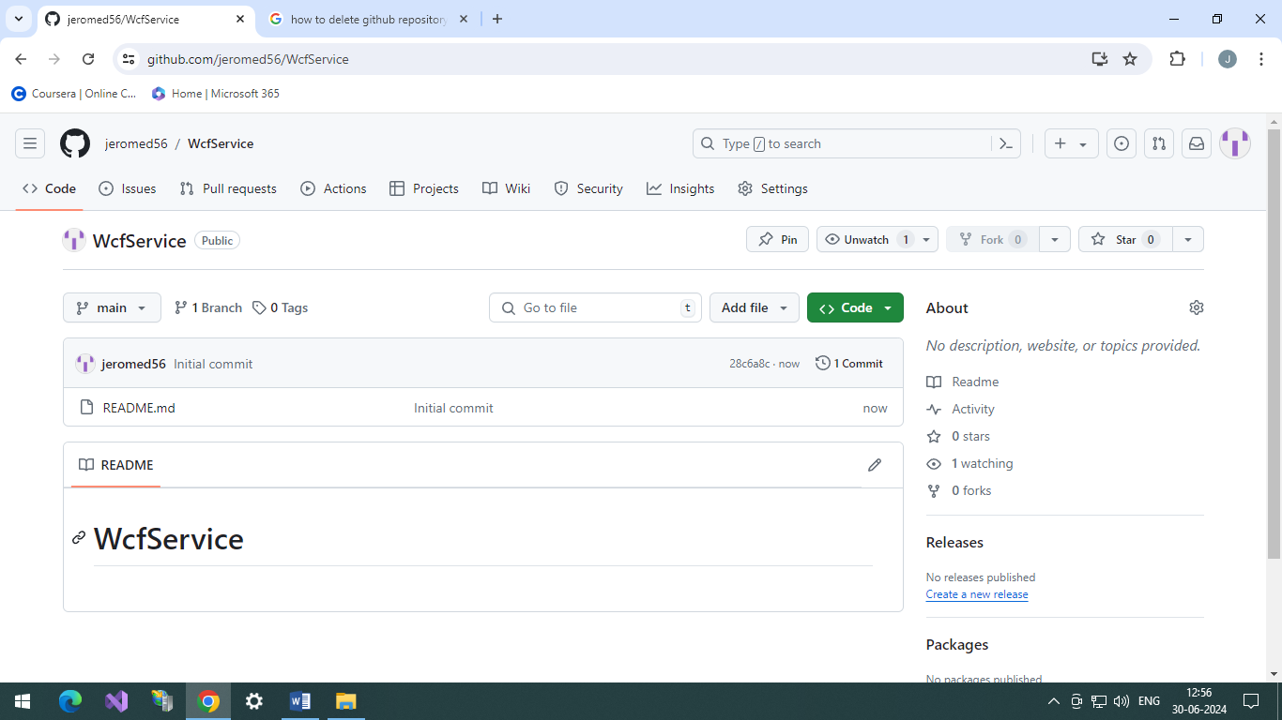

1. Install Git Bash on the local computer

<https://gitforwindows.org/>

1. After Git Bash installation a shortcut will appear on the desktop click to open.

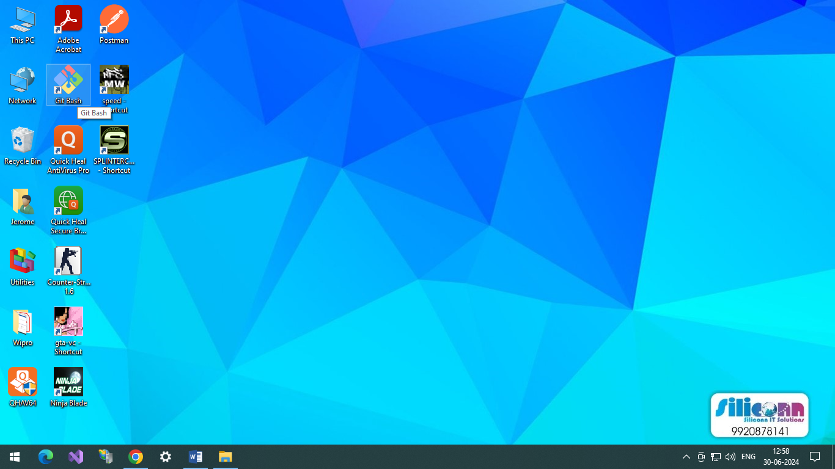

Click to open the GitBash application, a command like screen will be shown.

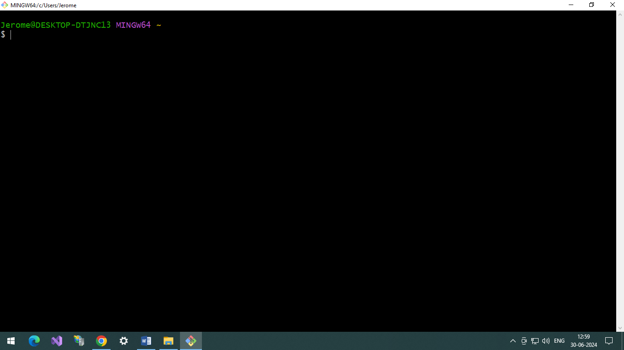

1. Go to the respective directory where you want to clone the git project. In our case we will be create the clone of git repository in the D:\GITHUB folder path.

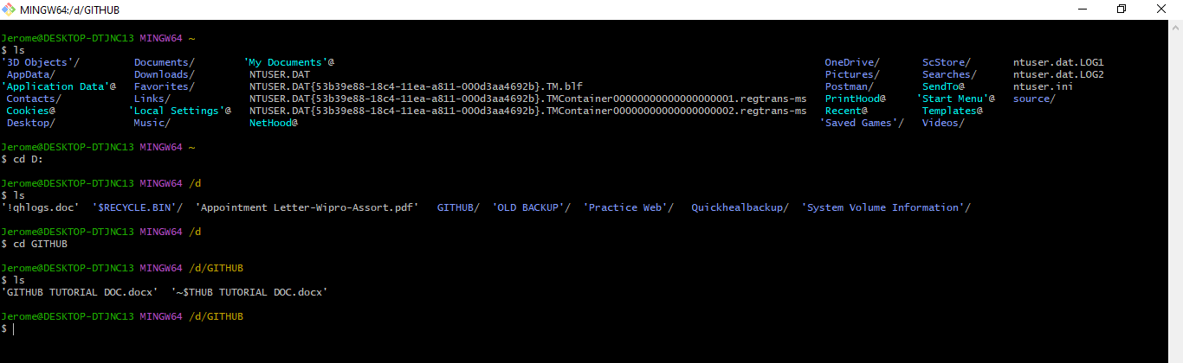

1. git clone url

e.g. git clone <https://github.com/jeromed56/WcfService.git>

Copy the git repository url from the git account and then execute the command in the git bash window

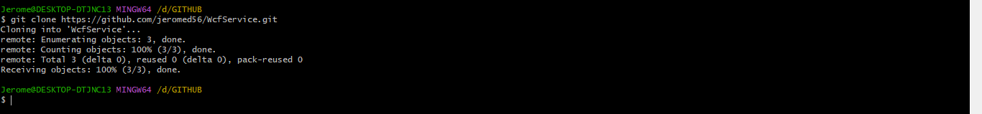

Now the git repository is create but it is empty , we will have to create or place the project inside the GITHUB\WcfService project folder.

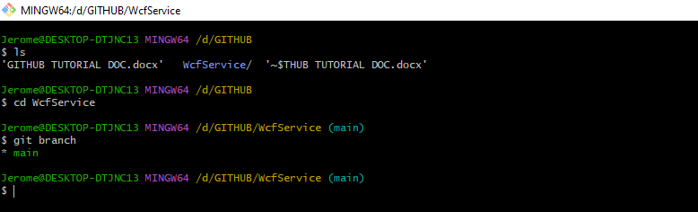

After add the project to the WcfService folder navigate to the git repository folder WcfService in the git bash window and execute ***git branch*** command this will show the status name of the branch , in our case it is the main branch as we have not yet created any child branches out of it.

**git branch** command is used to get the branch name in git repository.

1. git add . or git add filename

In this we will be staging our new file or changes in the file to the local git repository.

All the files within the local git repository will be tracked / staged by the git.

***git status***

This command get status all the file which were add newly or modified by the user and are ready to be staged and commit via git.

***git add .***

This command add all the files for the staging stage , after this subsequent command will be executed which will commit and push the files to the online git repository.

***git add filename e.g git add web.config***

This command adds only the specified file name for the staging stage.

Only the files present in the staging stage will be commited and pushed to the online git repository.

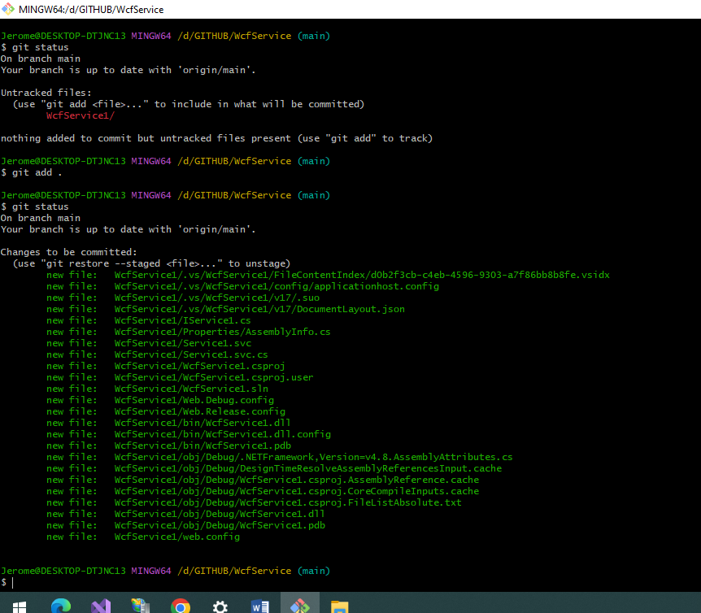

1. git commit -a , git commit -m “message remark” , git commit -am “message remark”

In this command the files available in the staging stage will be commited to the local git repository.

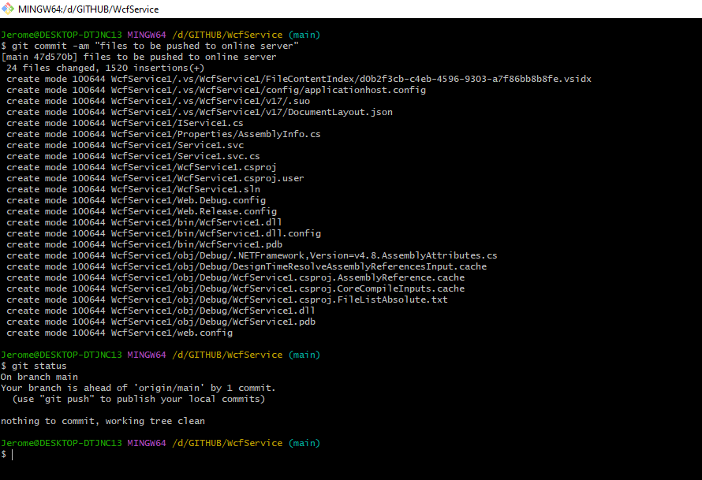

1. git push

This command pushes all file which were commited to the local repository , to the online repository folder in the current branch selected i.e main branch

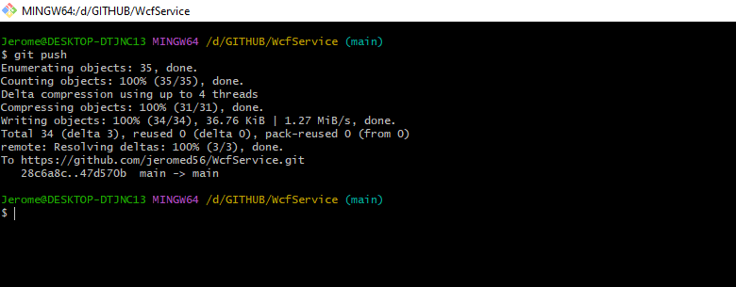

1. get pull

This command pull any changes present in the online repository folder to the local repository folder.

You can pull the changes based on the current branch selected.

In this case a new testfile.txt was added to online git repository, so to make it available in the local git repository we executed the ***git pull*** command.

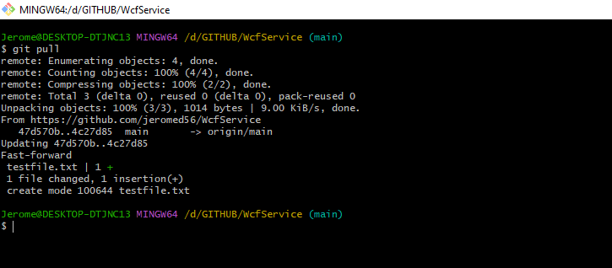

1. git stash , git stash pop